

**1103-GRT INSTITUTE OF ENGINEERING AND TECHNOLOGY**

**DEPARTMENT OF COMPUTER SCIENCE AND ENGINEERING**

**PROJECT TITLE**

***ELECTRICITY PRICE PREDICTION USING MACHINE LEARNING***

**LOGALAKSHMI.P**

3rd year, 5th semester

Reg no.:110321104026

Ph.no:8110071981

**Abstract:**

The Electric Price Prediction project aims to develop an accurate and reliable machine learning model for forecasting electricity prices in a dynamic and volatile energy market. Electric price prediction is crucial for both consumers and energy providers, enabling them to make informed decisions about energy consumption, procurement, and trading strategies. This project leverages historical electricity price data, weather information, and market indicators to create a predictive model that can assist stakeholders in optimizing their energy-related activities.The project's main objectives are Data Collection and Preprocessing: Gather historical electricity price data from various sources, including energy market databases, and collect relevant weather data such as temperature, humidity, and wind speed. Feature Engineering: Identify key features that influence electricity prices, including supply and demand factors, time of day, day of the week, and seasonal patterns. Model Selection and Development: Explore various machine learning algorithms, including regression models, time series forecasting methods, and deep learning techniques, to build predictive models. Training and Testing: Train the chosen model on historical data, using a portion of the dataset for training and the remainder for testing and validation. Real-time Prediction: Implement the selected model in a real-time prediction system that continuously updates forecasts based on the latest data. Evaluation and Fine-tuning: Continuously monitor the model's performance and fine-tune it as needed to adapt to changing market conditions. Regularly update the model with new data to maintain its accuracy. Deployment and Integration: Integrate the electric price prediction model into energy management systems, trading platforms, and consumer applications to provide actionable insights and support decision-making processes.

**Problem Definition:**

The problem is to develop a predictive model that uses historical electricity prices and relevant factors to forecast future electricity prices. The objective is to create a tool that assists both energy providers and consumers in making informed decisions regarding consumption and investment by predicting future electricity prices. This project involves data preprocessing, feature engineering, model selection, training, and evaluation

**Introduction:**

Electricity is a fundamental commodity in modern society, powering homes, businesses, industries, and essential infrastructure. In today's dynamic energy landscape, the cost of electricity can vary significantly, driven by a complex interplay of factors including supply and demand dynamics, weather conditions, market forces, and regulatory changes. This variability poses significant challenges for consumers, energy providers, and market participants who seek to optimize their energy-related activities, manage costs, and make informed decisions.

The Electric Price Prediction project addresses these challenges by harnessing the power of machine learning to develop an advanced forecasting system for electricity prices. The ability to accurately predict electricity prices is of paramount importance, as it empowers consumers to adjust their energy consumption patterns, energy providers to optimize their supply strategies, and traders to make profitable decisions in energy markets. Additionally, such predictions can support the integration of renewable energy sources and enhance grid stability.This project leverages historical electricity price data, weather information, and market indicators to create a predictive model capable of providing reliable forecasts of future electricity prices. By doing so, it aims to offer a comprehensive solution to the following key objectives:

1.**Data-Driven Insights:** Utilizing vast datasets of historical electricity prices and weather conditions, this project seeks to uncover hidden patterns, trends, and correlations that influence electricity price movements. Such insights can enable stakeholders to better understand the factors driving price fluctuations.

2. **Improved Decision-Making:** Armed with accurate price forecasts, consumers can make informed decisions about when to consume energy to reduce costs, while energy providers can optimize their generation and distribution strategies to meet demand efficiently. Traders and market participants can identify opportunities for profitable trading.

3. **Risk Mitigation:** Energy market participants often face substantial financial risks due to price volatility.

Reliable price predictions allow for better risk management, helping companies to hedge against adverse price movements and ensure financial stability.

4. **Energy Efficiency and Sustainability:** Predicting electricity prices supports the integration of renewable energy sources, as consumers can align their energy consumption with periods of lower prices and increased renewables generation, contributing to a more sustainable energy ecosystem.

5. **Market Transparency:** Access to accurate price forecasts enhances transparency in energy markets, fostering fair competition and facilitating the transition to cleaner energy sources.This project represents a significant advancement in the field of energy analytics and machine learning.

By harnessing the capabilities of modern data science and predictive modelling , it aims to empower individuals, businesses, and industries to navigate the complexities of the electricity market with confidence, ultimately contributing to a more efficient, cost-effective, and sustainable energy future.

Certainly, here's some additional content that you can include in your project introduction to provide more context and depth:

**6.Energy Market Dynamics:**The energy market is undergoing a profound transformation driven by factors such as the increasing adoption of renewable energy sources, advancements in grid technologies, evolving regulations, and changing consumer behaviors. These changes have introduced unprecedented levels of uncertainty and volatility in electricity prices. Traditional forecasting methods struggle to capture the nuances of this new energy landscape, making it imperative to develop innovative and data-driven approaches to predict price fluctuations accurately.

**7.Importance of Electricity Price Prediction:**Accurate electricity price prediction holds immense value for a wide range of stakeholders:

**8.Consumers:** Household and industrial consumers can benefit by scheduling energy-intensive activities during periods of lower prices, thus reducing their electricity bills and environmental impact.

**9.Energy Providers:** Electricity suppliers can optimize their generation and distribution strategies, reduce operational costs, and offer innovative pricing structures to attract and retain customers.

**10.Renewable Energy Integration:** The integration of intermittent renewable energy sources, such as solar and wind, into the grid depends on precise price forecasts to balance supply and demand effectively.

**11.Energy Trading:** Traders and investors in energy markets rely on price predictions to make informed decisions regarding energy trading, hedging, and risk management.

**12.Grid Operators:** Grid operators can enhance grid stability by anticipating demand surges and adjusting their operations accordingly, minimizing the risk of blackouts and system failures.

**13.Challenges and Complexity:** Electricity price prediction is a complex task due to the interplay of numerous variables, including but not limited to:

* Demand patterns influenced by time of day, seasonality, and economic factors.
* Weather conditions impacting energy generation and consumption.
* Market dynamics, such as fuel prices, regulatory changes, and supply-demand imbalances.
* The integration of renewable energy sources, which introduce intermittent and less predictable generation patterns.

**14.Machine Learning and Data Science Approach:**This project adopts a data-centric approach, leveraging the capabilities of machine learning and data science. By analyzing large datasets of historical price data and related factors, we aim to develop a model capable of capturing the intricate relationships between these variables and providing accurate electricity price forecasts.

**15.Project Significance:** The Electric Price Prediction project represents a significant contribution to the fields of energy economics, sustainability, and machine learning. By addressing the pressing need for reliable electricity price forecasts, this project aligns with global efforts to create a more sustainable, resilient, and efficient energy ecosystem. The outcomes of this research are poised to benefit society, the economy, and the environment by promoting responsible energy use and supporting the transition towards a cleaner and more sustainable energy future.

**DESIGN THINKING:**

Data Source: Utilize a dataset containing historical electricity prices and relevant factors like date, demand, supply, weather conditions, and economic indicators.

Data Preprocessing: Clean and preprocess the data, handle missing values, and convert categorical features into numerical representations.

Feature Engineering: Create additional features that could enhance the predictive power of the model, such as time-based features and lagged variables.

Model Selection: Choose suitable time series forecasting algorithms (e.g., ARIMA, LSTM) for predicting future electricity prices.

Model Training: Train the selected model using the preprocessed data.

**Dataset Link:**

https://www.kaggle.com/datasets/chakradharmattapalli/electricity-price-prediction

**ELECTRICITY PRICE PREDICTION MODEL:**

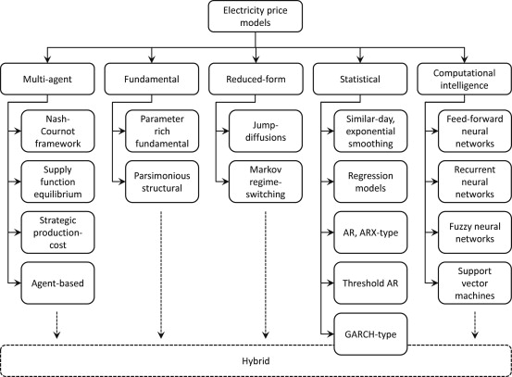

**ARCHITECTURE:**

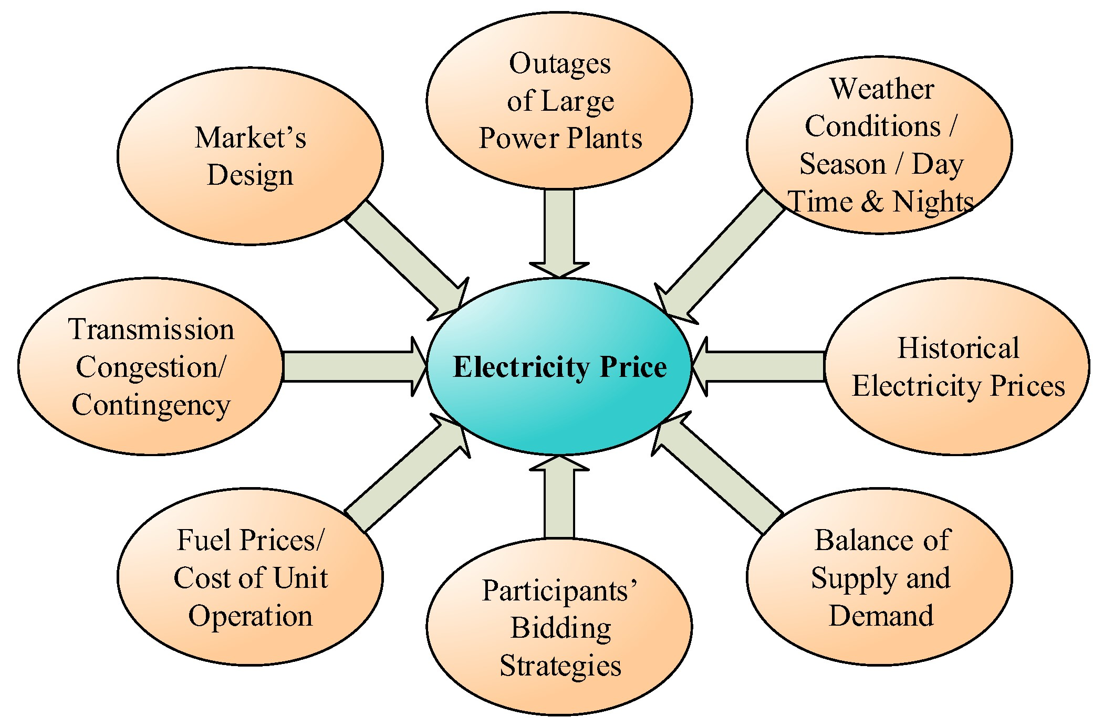

**THANKING YOU.**